6. The Strait of Gibraltar

Worksheet 2: Learning what STRAITS, ISTHMI/ISTHMUSES, CANALS are
Grouping: A.1, A.2, A.3, A.4 (individual) and A.5 (whole class)
- Look at the pictures of a strait and an isthmus.
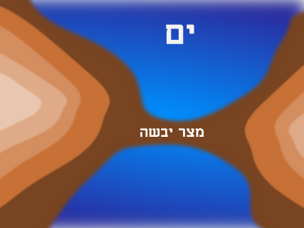
Source:http://en.wikipedia.org/wiki/Strait http://upload.wikimedia.org/wikipedia/commons/8/8a/Isthmus.png
STRAIT (or STRAITS) ISTHMUS
- Can you describe what each one is?
________________________________________________________________________________________________________________________________________________________________________________________________________________________________________________________________
- To check out your answers, and for more information, read the following text and fill in the blanks below:
STRAITS, ISTHMI/ISTHMUSES, CANALS
(from Wikipedia: http://en.wikipedia.org/wiki/Isthmus
http://en.wikipedia.org/wiki/Strait )
A strait is a narrow, navigable channel of water that connects two larger bodies of water. This channel of water lies between two land masses. Many straits are economically important. Straits can lie on important shipping routes, and wars have been fought for control of these straits.
An isthmus is a narrow strip of land that connects two larger bodies of land. An isthmus is the opposite of a strait - a narrow body of water that connects two larger bodies of water. Therefore, straits are the converse of isthmi. That is, while straits lie between two land masses and connect two larger bodies of water, isthmi lie between two bodies of water and connect two larger land masses.
An isthmus is usually a good place to build a canal to connect the two bodies of water on either side of the landmass. They create a shortcut. Numerous canals, have been constructed to connect two bodies of water over land.
For example, the Suez Canal adjoins the Mediterranean Sea and the Indian Ocean, cutting across the Isthmus of Suez to connect the Mediterranean Sea and the Gulf of Suez/Red Sea. It is the fastest crossing from the Atlantic Ocean to the Indian Ocean.
Another well known Canal is the Panama Canal which connects the continents of North America and South America and also the North Atlantic and Pacific Oceans.
Please fill in: .…………….…………….. and ……..………………….. are natural formations. …………………………… are manmade formations.
- If in your mother tongue, you use any of the words isthmus, canal, strait, and you want to find its origin, you can go to http://www.enl.auth.gr/links/findex.htm and look it up in the Webster dictionary.
- As a class, check your answers and exchange information.

Answer sheet for B
The students will answer this in their own words, but they should clearly define that a “strait” is a strip of water between two pieces of land and an “isthmus” is a strip of land dividing two seas.

Answer sheet for C
Please fill in: .……straits….….………. and ………isthmuses……... are natural formations. …………Canals………….… are manmade formations.

Answer sheet for D
Excerpts from Webster dictionary:Origin of ISTHMUS: Latin, from Greek isthmos
First Known Use: 1555
Origin of STRAIT: Middle English, from Anglo-French estreit, from Latin strictus strait, strict, from past participle of stringere
First Known Use: 13th century
Origin of CANAL: Middle English, from Latin canalis pipe, channel, from canna reed. First Known Use: 15th century.

