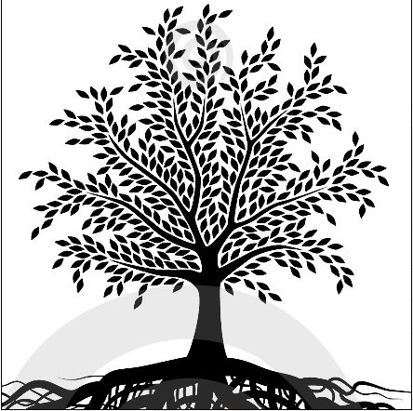
Labelling parts of a tree; figurative senses of parts of a tree

Worksheet 2
 Parts of a tree can also be used in a figurative sense in English. Look at these definitions going with the words root, trunk, branch, leaf, crown. Write the appropriate word next to its definition. Check with a partner.

- a large strong box with a lid used for storing things or for carrying them when you travel. __________
- a sheet of paper, especially in a book. __________
- a circular decoration that a king or queen wears on their head as a symbol of power, often decorated with jewels. __________
- the __________ of a number is another number that, when multiplied by itself a particular number of times, equals that number.
- a shop or office representing a large company or organization in a particular area. __________
2 With your partner, use a monolingual dictionary (on paper or online) to make a list of other uses of these words in English.

In class, read out uses of trunk - leaf - crown - root - branch and find out which part of the tree the definition is alluding to.
What are parts of a tree called in your language? Ask members of your family or other people sharing your first language. Make a list, and collect other uses of these words.
Write two or three figurative uses of parts of a tree used in your first language in English. Ask a classmate to point to the appropriate part of the tree on the picture.
Assessment
Learners check their findings with the solution of the worksheet

Answers Worksheet 2: trunk - leaf - crown - root - branch

