UNIT 1: Exploring diversity

Activity 1.2: CONTINENTS
-  Here is a photocopy of the map of the world.

Worksheet 1.2.1
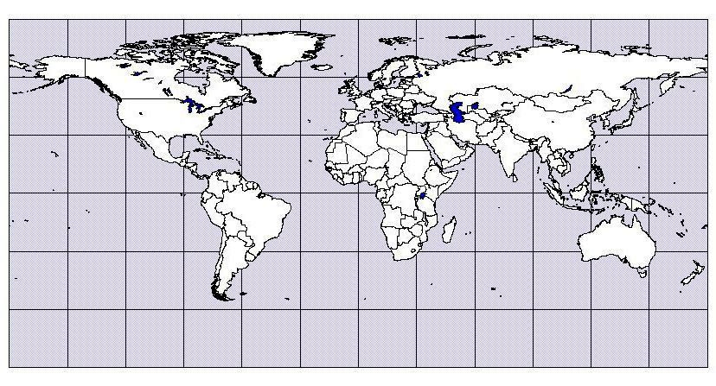
In pairs, write the English names of the continents on your map.

AFRICA, ANTARCTICA, NORTH AMERICA, EUROPE, ASIA,
SOUTH AMERICA, AUSTRALIA
... Follow up tasks for the whole class:
- Check your answers in the whole class and show the continents on a big map.
- Can you say the names of the continents in another language?

