8. Time zones
Notes for the teacher:
- 1. This Worksheet explores the issue of time across the world. It contains information that will help students understand how time differs among countries.
- 2. Perhaps, if some of the students have a friend or a relative abroad, they are aware of the difference in time with particular countries. The teacher could ask and find out. Then, she/he could ask it anybody knows why there is such a difference and the whole class could talk about it, for everybody to understand how it works.
- It would be very useful if the teacher used a globe to demonstrate the Earth’s rotation around the sun and how at any given time, some places are in daytime, others in night time and others in between. Do not talk about time zones at this point.
- You could spot your country on the globe and the countries which students have their friends in and explain why those countries are ahead or behind in time.
- Remember, each day starts in the east, so all the places that are to the right of your country on the globe/map have already experienced the part of the day that you are presently experiencing. The countries that are to your left are waiting for the day “to move towards them”.
- After all this information is understood by the students, the teacher could give the students the photocopies and let them find out themselves about the time zones, from Worksheet 1. Then, they can do the rest of the tasks.

Duration: 60 minutes
Necessary material:
- Photocopies of the Worksheets
- Dictionaries (on line and hard copies)
- Access to the Internet (optional)
- A globe

Worksheet 1: Finding out about the time zones
Grouping:  (individual)
- Have you ever felt you needed more time and wished you could turn the clock back? Well, actually you can. If you travel with a supersonic plane, you can arrive to your destination earlier than you started your trip. Be careful, though, to travel westwards. Because, only the places that are west of you are earlier in time. On the contrary, if you decide to travel eastwards, you will lose some valuable time, which you will never be able to regain.
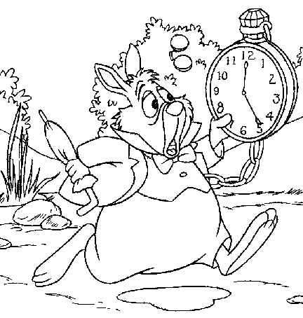
Look at the following map. The whole world is divided in 24 time zones. Each zone represents an hour difference in time. Find your home place on the map. The places in the first zone to the left are one hour earlier, the places in the second zone are two hours earlier and so on. The places in the first zone to the right are one hour later, the places in the second zone are two hours later and so on.
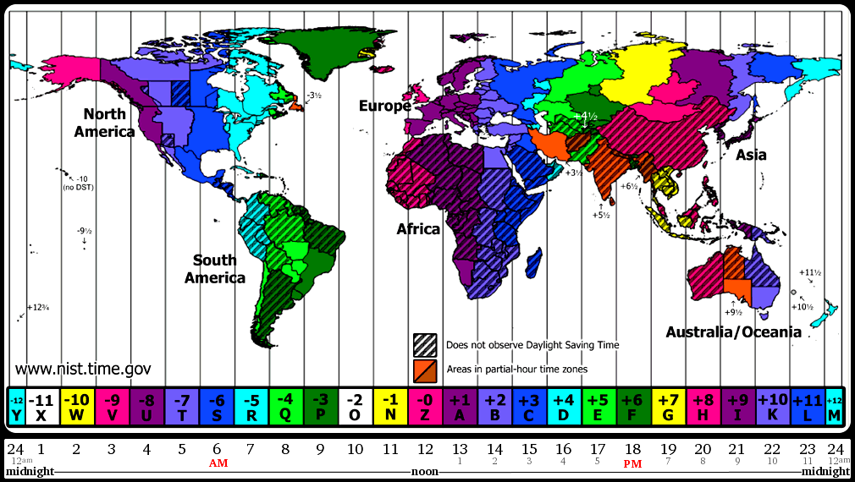
Time moves from the east to the west.
The Greenwich Observatory in the
UK is the centre of time measuring Map from http://nist.time.gov/images/worldzones.gif

- Using the above map, can you name two places whose time is ahead of yours and two places whose time is earlier than yours? Can you also calculate, what time it is there?
Ahead: …………………………………… …….………………………………….
Earlier: …………….…………………….. …………………………………………
Useful information: You can go to http://www.what-time-is-it.com/ to find out what time it is in various places of the world.

