UNIT 1: Exploring diversity

Activity 1.4: MY COUNTRY

Worksheet 1.4.1
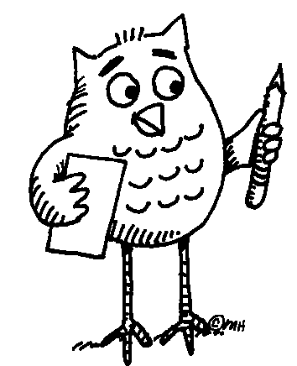 Work in pairs.
First, write the name of your country in the middle. (You can use English or your mother tongue.) Then write the names of languages spoken in your country by people who live there (not tourists).
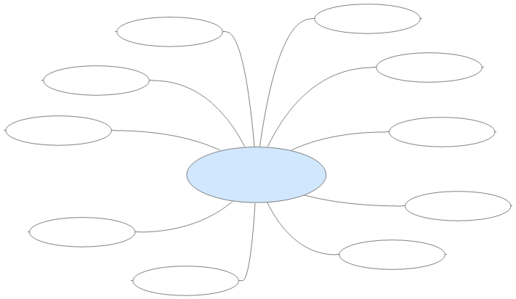

... Follow up tasks for the whole class:
- Read the names of the languages in English and in the language(s) spoken in your school or class.
- What languages do tourists speak in your country?

