UNIT 1: Exploring diversity

Learner worksheet 1.2: CONTINENTS
Materials required: maps below

Worksheet 1.2.1
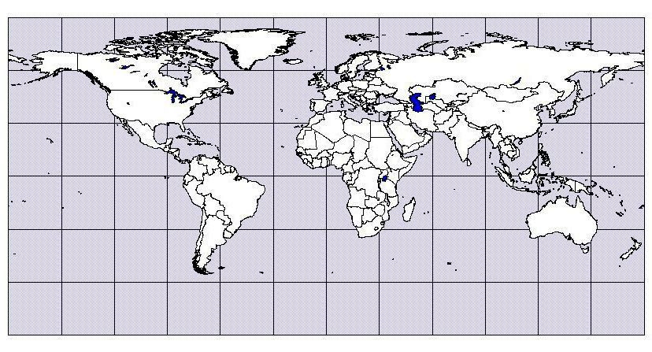
In pairs, write the English names of the continents on your map.
AFRICA, ANTARCTICA, NORTH AMERICA, EUROPE, ASIA,
SOUTH AMERICA, AUSTRALIA

Grouping:  , ...
Here is a photocopy of the map of the world.
... Follow up tasks for the whole class:
- Check your answers in the whole class and show the continents on a big map.
- Can you say the names of the continents in another language?
Assessment:
Attention should be paid to correct pronunciation of the new words in English.
Notes for the teacher:
Timing: 5 minutes
References:
http://www.zemepis.com/smsvet.php

