6. The Strait of Gibraltar

Worksheet 3: Exploring the languages around the Gibraltar strait
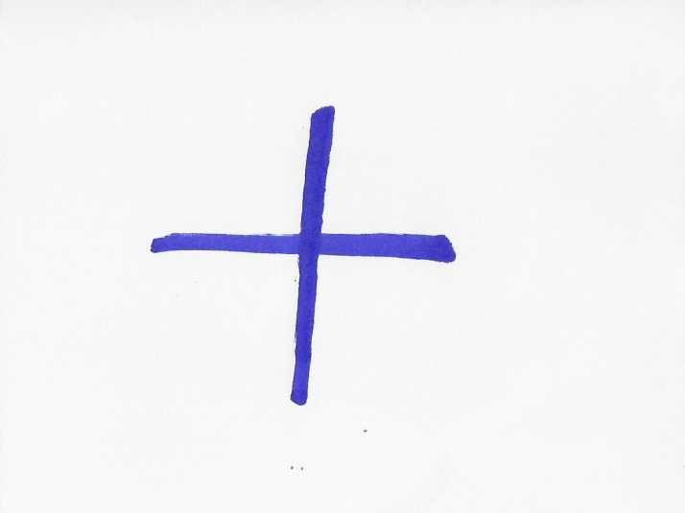
Grouping: A.1, A.2, A.3,  (pairs) or (small group) and A.4 (whole class)
- Below are the words “Gibraltar Strait” in the languages spoken in the three countries around the strait of Gibraltar. Can you guess in which country you will see a sign with the following words on it? (Put the initial letter of each country in the brackets).
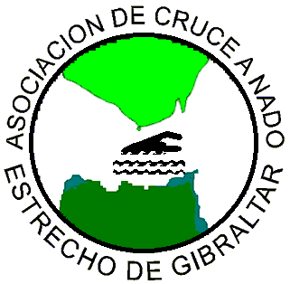
(picture from
http://www.acneg.com/)

1)“ Estrecho de Gibraltar” ( )
2) “مضيق جبل طارق” ( )
3) “Gibraltar Strait” ( )

- Here are some more words in the languages spoken around the strait of Gibraltar. They have the same meaning in the horizontal cells. Can you mark the countries where they are spoken by putting the initial of the country in the brackets next to the words? If you wish, you could also help each other to memorize them. (The bold letters indicate where the stress is):

Bienvenido/a ( ) | مرحبا /Merhaba / ( ) | Welcome ( )
سلام / Salam / ( ) | Hola ( ) | Hello ( )
Gracias ( ) | Thanks ( ) | شكرا /Shukran/ ( )
…سميتي /Smiyti…/ ( ) | mi nombre es ….. ( ) | My name is…. ( )
- Think of the countries in our Earth presentation: Can you think which of these words you could use to communicate in South America, around the Red Sea, in Cuba, Mexico and North America? Name as many countries as you can, where you think that these words would be useful to you and write down the countries inside the cells of the above table.
- In one of the areas we saw in our presentation, these words would not help you to communicate, because neither Arabic nor English or Spanish is spoken there. Which area is that?
- As a class, check your answers and exchange information.
Useful information: For more Moroccan Arabic you can visit http://www.speakmoroccan.com/

Answer sheet for A
- “ Estrecho de Gibraltar” ( Spain, Ceuta ),
- “مضيق جبل طارق” ( Morocco ),
- “Gibraltar Strait” ( Gibraltar ).

Answer sheet for B
Bienvenido/a (Spain)  Cuba, Mexixo, South America (Argentina, Peru, Chile, Uruguay, Venezuela, etc). (Note: Spanish is spoken in almost all S. American countries, but in the largest one, Brazil, people speak Portuguese). | مرحبا /Merhaba / ( ) | Welcome ( )
سلام / Salam / ( Morocco)  Countries around the Red Sea (Arabic is spoken in Saudi Arabia as well as the rest of the countries in the Arabian peninsula: Yemen, Qatar, Oman, Bahrain, Kuwait and United Arab Emirates. It also spoken in Egypt, Jordan but also in Syria, Iraq, Tunisia, Algeria, Libya and Sudan) | Hola ( ) | Hello ( )
Thanks (Gibraltar)  North America (USA, Canada, but also in Australia,  New Zealand, Ireland) | Gracias ( ) | شكرا /Shukran/ ( )
…سميتي /Smiyti…/ ( ) | mi nombre es ….. ( ) | My name is…. ( )

Answer sheet for C
In South America, Cuba and Mexico we could use the words: Bienvenido/a, Gracias, mi nombre es….
Around the Red Sea we could use the words: مرحبا /Merhaba /, شكرا /Shokran/ , مرحبا /Merhaba / .
In North America we could use the words: Welcome, Thanks, Hello.

Answer sheet for D
The area around the Black Sea is the place where we cannot use either Arabic, or English and Spanish.

