2. Parasites around the world

Worksheet 2
- Writing task: Study the prevalence, life cycle, diagnosis etc of head louse (Pediculus humanus)
- A Describe your day as a parasite.
- B Describe an adventure as a parasite
- C This is how I died.
- Work in pairs. Spot the prevalence areas of 1-5 parasites in the world map. Define the symbols (colours) to each other.

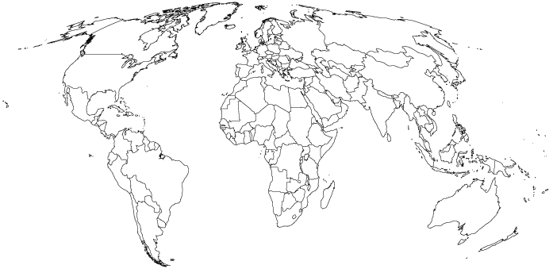
- Classroom discussion
Some people are called “parasites”. They live off others and give nothing in return. Find some examples from your society, justify your opinion. What needs to be done in order to get rid of them/to change them? Present your ideas in the class.
- Interview
The problem of parasites is not just limited to so called third-world countries. We are just as much at risk as anyone else. Visit a pharmacy and interview the pharmacist about the most common parasites in humans currently. Ask about the ways to get rid of them. Write a report on the results or get ready for a classroom presentation.
Prepare your questions to the pharmacist in advance. You can ask help from your teacher.

