worksheet 5: Number systems
Resources: worksheet 5
Timing: 25 minutes or more (depends on the learners´ involvement and interest)
Grouping: 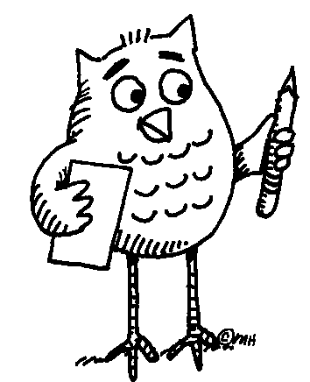 ( ... )
Focus on content: calculations
Focus on languages: number systems in a variety of cultures/languages 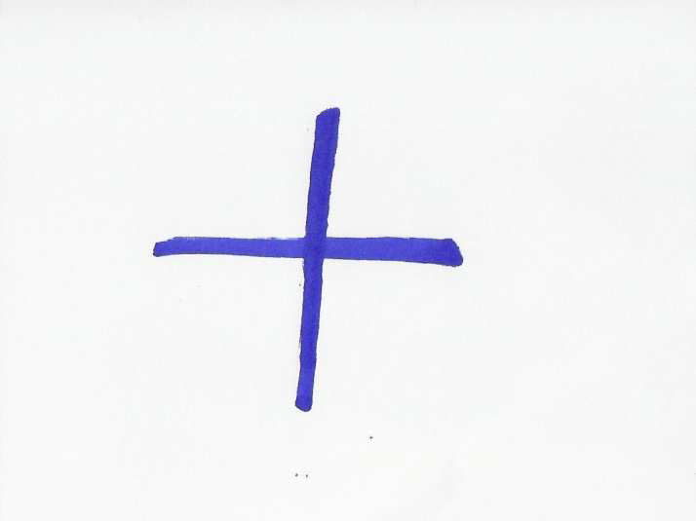

Learner worksheet 5: NUMBER SYSTEMS


Task 1: Study the following text carefully in order to succeed in Task 2.
- Base 10 (b = 10) Decimal system (counting by 10´ or 10 count system) is the most widespread. It is associated with the use of fingers on both hands. In the past it was used e.g. by the Inca of South America. The system requires digits to represent the numbers from zero to nine.
- Base 12 (b = 12) The system was used in English and German: e.g. units of measure (12 inches = 1 foot), old money (12 pence = 1 shilling), and also in terms such as a dozen = 12. Some of the units are still in use.
- Base 20 (b = 20) The system was used in French and Dutch. The scale may have originated in finger- and toe-counting. In the past it was used e.g. by the Maya of Central America, or the Yoruba of West Africa. The system requires the use of both digits (numbers from zero to nine), and letters (10 = A, 11 = B, 12 = C, 13 = D, 14 = E, 15 = F, 16 = G, 17 = H, 18 = I, 19 = J).
Task 2: Before you continue, try to find the countries mentioned in Task 1 on the map.
- Compare: 2510 = 2 . 101 + 5 . 100 = 2 . 10 + 5
    - 25₂₀ = 2 . 20¹ + 5 . 20⁰ = 2 . 20 + 5 = 45₁₀
- Convert to base 20. Example: 144₁₀ = 7 . 20 + 4 . 1 = 7 . 20¹ + 4 . 20⁰ = 74₂₀
66₁₀
78₁₀
520₁₀
- Can you think of more problems that your friends might like to solve?

... Follow up activity for the whole class (in English or your mother tongue
Can you tell the class about the number system(s) used in your culture?
Notes for the teacher: Worksheet 5
Task 1 - Additional information:
Base 10 comes from the Harappan civilization in the Indus Valley (3000 BC) and most probably came to Europe via the translation of Arab science and mathematics. Important social and technical factors in the spread of base 10 was the development of accounting in the Italian City States in the 14th and 15th centuries, the use of paper technology and ink for writing, and Gutenberg’s printing press.
Many number systems are mixed base systems – a relic from the times when people counted different things in different ways. Great Britain only changed over to metric in the 1970s. Before there were pounds, shillings and pence (12p = 1s; 20 s = £1); yards, feet and inches (12 inches =1 foot, 3 feet =1 yard, etc.) Recently Britain had an amendment to the law that now allows shopkeepers to sell things in old units (provided they show the metric equivalent).
Task 2b
Grouping: ( ... ): individual work first. Later the learners can compare their results with the others in class. Finally, everybody should learn the correct answers.
Answer sheet:
66₁₀ = 3 . 20 + 6 = 36₂₀ This could be written as 3,6
78₁₀ = 3 . 20 + 18 = 3I₂₀ This could be written as (3,18)₂₀ i.e. 3 . 20 and 18 ‘units’
520₁₀ = 1 . 20² + 6 . 20¹ + 0. 20⁰ = 160₂₀
Task 2c
If the learners come up with their own problems for the others to solve, the results can be checked on: http://www.kaagaard.dk/service/convert.htm

