UNIT 3: Meeting new friends in our town

Activity 3.2: OUR TOWN - OUR REGION
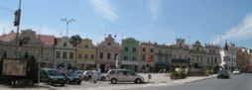

Worksheet 3.2.1
-  1. On your own, read the text:
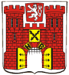
The Highlands region has much to be proud of. It is of historical and cultural interest for tourists not only from our country but also from abroad. The town of Havlíčkův Brod is mentioned as a gateway to the Czech part of the Czech-Moravian borderlands. In the course of its existence, it has always been an important center of the region. It belongs to the oldest towns on the Sázava River - it is more than 750 years old, and qualifies almost as a historical preserve. Its older name (Deutsch Brod) was linked to German miners. Some of them came to work in the nearby village of Silver Mountains in 1503. Later the town was named after Karel Havlíček Borovský, a journalist who was active in the Czech National Revival. Of the important personalities we should also recall two musicians and composers: J. V. Stamic, the founder of the Mannheim Instrumental School, who was born in Brod, and Bedřich Smetana, who studied here.
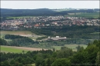 | 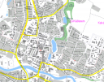 | 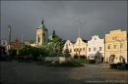 | 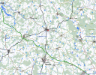

- Work in your group (4 pupils) -. First discuss the following questions in the mother tongue. Then write the main ideas in English.

What I know / what I read about our town / our region: | What else I would like to learn and tell our new classmates:

Compare your answers with other groups.

