Worksheet 3
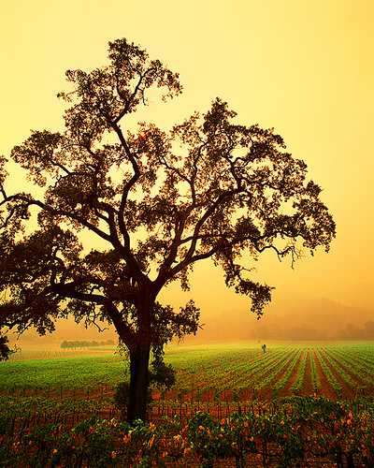
- What does a tree make you think of? Look at the picture and collect 5 to 10 words that you link to the word tree.
http://farm1.static.flickr.com/233/445631386_b4ea2896fc.jpg?v=1234922551
- In English, the word tree makes people think of the countryside, greenness, strength and longevity. Others may think of leafless trees connoting winter and hardship. Moreover, specific trees might make people think of certain things, the word oak, for instance, is often used in connection with words such as solid, royal, old.
What are speakers of your first language thinking of in connection with trees? Are there any specific trees in your first language‘s culture that are used in connection with other words? Ask these questions to three people of your family. Take notes of their answers and bring them to class (the notes, not the people ;-) ).
-  Go to http://www.logosdictionary.org and type the name of a tree in your first language, then click on search. How many translations are being offered for your tree? Are some of them similar to the name in your first language? Try other trees. What can you find out?
- () Compare your findings in groups. In your group, design a poster with the outline of a tree and the information that you have collected.

