Addictively tasty
For the Student
Sofie JONCKHEERE, Arzu BASOGLU & Kristel PROVOST
LEARNER TEMPLATE

Addictively tasty

Sofie JONCKHEERE, Arzu BASOGLU & Kristel PROVOST

-------------------------------------------------------------------------------------------------

1. A delicious ingredient

Grouping: 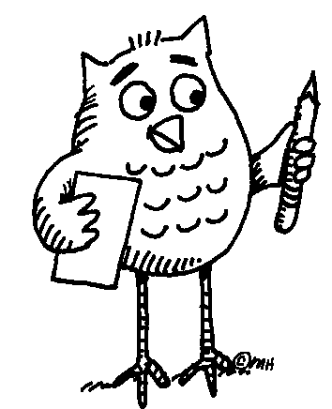

Worksheet 1

Which ingredient do you recognise below? _______________________

Which languages do you recognise? Write the language next to the word.

1. čokolada ……………………………….
2. czekolada ……………………………….
3. ciocolată ……………………………….
4. cioccolato ……………………………….
5. sjokolade ……………………………….
6. chocolate ……………………………….
7. schokolade ……………………………….
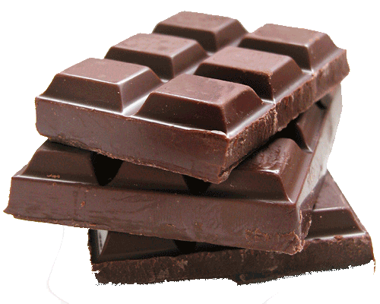
8. choklad ……………………………….
9. chocolade ……………………………….
10. chocolat ……………………………….

Which languages resemble each other? _________________________
________________________________________________________________________________________________________________________
Have you any idea why that is so? ______________________________ ________________________________________________________________________________________________________________________

----------------------------------------------------------------------------------------------------------
2. Europe

Grouping: (whole class)

Worksheet 1

In which European countries are these languages official languages? Try this for 6 languages.

Language: _______________  Countries: ____________________  ____________________ | Language: _______________  Countries: ____________________  ____________________ | Language: _______________  Countries: ____________________  ____________________
Language: _______________  Countries: ____________________  ____________________ | Language: _______________  Countries: ____________________  ____________________ | Language: _______________  Countries: ____________________  ____________________

Can you find these countries on the map of Europe?

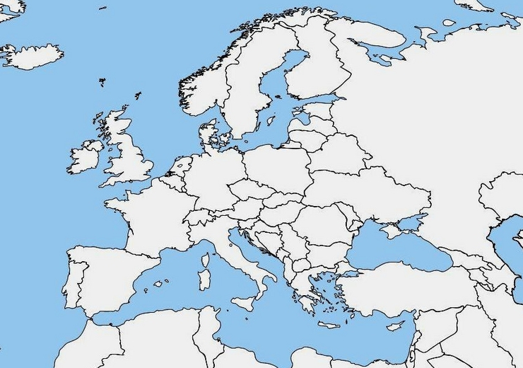

Afterwards you can check the atlas if you were right.

----------------------------------------------------------------------------------------------------------

3. Word search

Grouping:

Worksheet 1

Try to find the following words: sjokolade, chocolade, schokolade, chocolate, czekolada, cioccolato, choklad and chocolat

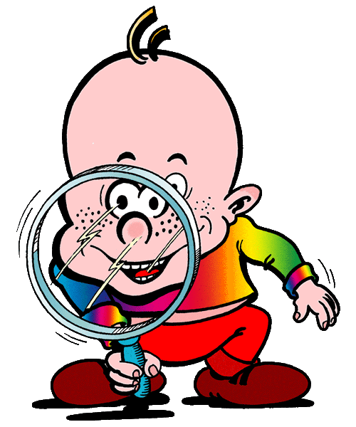

T F N S H W R E O O R E I F
F N E J C W I R M O R G D F
T Z D O Z N Q O I T C F S H
I A E K E N S M D A Q C E S
O I U O K E N R S L H R D D
F T O L O N T A L O C O H C
L F N A L F A A C C D C E C
U R P D A H I O L C O R E S
H M C E D A L O K O H C S A
S I S H A A I N I I C K S S
T E E T D M T J C C I O R I
D A H E S C E N Q A V C H H
T W N A P M S D A L K O H C
P G N N T C D L I R M C B A
----------------------------------------------------------------------------------------------------------

4. The origin of chocolate

Grouping:

Worksheet 1
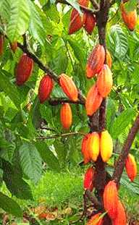
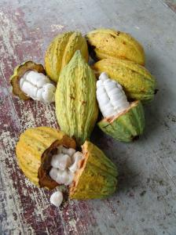
The premier contact of the Western world with Kakao took place in 1528 when the Spanish explorador Fernando Cortez returned from Mexico with Kakao. At that temps cacao was used to make une boisson. The cacaobonen were very duur. Only rich insanlar could payer them. Only in 1900 Kakao became a national drink due to a sharp drop in prix of Kakao. The main ingredient of chocolate is Kakao, made from cacaobonen. They come from the fruta of the Kakaobaum. Kakaobaumen grow in warm and humid tropical ülkeler, surtout in the ülkeler around the équateur. The best-known fournisseurs are Indonesia, Ecuador, Kenia, Ivory Coast... A Kakaobaum has to grow tres tot four jaren and can become quinze metros hoog. Most Kakaobaumen are pruned and become only vier metros hoog. That way it’s easier to pick the Früchte. Every arbre gives about dertig to veertig Früchte par an. The tree has bloemen all year long. Big, hard Früchte grow out of every bloem. After about cinco maanden the Früchte are ripe. After these vijf aylar they can be picked. The ripe fruits are geel. They are about zwanzig Zentimeter long. Every fruta contains about quarante tohumlar. These seeds are the cacaobonen. Kakao is made of these tohumlar. Every year an arbre delivers bir to twee kilo kakao. They open the Früchte with a couteau. They take out the bonen and put them in bins. The bins are covered with big feuilles. After a semaine the bonen are bruin. The bonen are taken out of the bins and put in the Sonne to dry. The bonen are put in big sacs and transported to Europe by Fahrzeug. De sacs are unloaded in the haven of Amsterdam and they take them to the chocolate fabrics by camions. In the fabrics they are converted into chocolate.
Answer the following questions:
Who brought the cacao to Europe? _____________________________
In which year was that? ______________________________________
Which country does the cacao come from? _____________________
Where do cacao trees grow? __________________________________
________________________________________________________________________________________________________________________
How much cacao does a cacao tree deliver a year? _____________
How many seeds does a cacao tree fruit contains? _______________

----------------------------------------------------------------------------------------------------------

5. Quartet

Grouping:

----------------------------------------------------------------------------------------------------------

6. Alphabet game

Grouping:

Worksheet 1

Try to make a word with every letter of the alphabet. The words must have something to do with this lesson about chocolate. Translate this word into your mother tongue and in another language you know.
English | Your mothertongue | Another language
A____________________ | ____________________ | ____________________
B____________________ | ____________________ | ____________________
C____________________ | ____________________ | ____________________
D____________________ | ____________________ | ____________________
E____________________ | ____________________ | ____________________
F____________________ | ____________________ | ____________________
G____________________ | ____________________ | ____________________
H____________________ | ____________________ | ____________________
I____________________ | ____________________ | ____________________
J____________________ | ____________________ | ____________________
K____________________ | ____________________ | ____________________
L____________________ | ____________________ | ____________________
M____________________ | ____________________ | ____________________
N____________________ | ____________________ | ____________________
O____________________ | ____________________ | ____________________
P____________________ | ____________________ | ____________________
Q____________________ | ____________________ | ____________________
R____________________ | ____________________ | ____________________
S____________________ | ____________________ | ____________________
T____________________ | ____________________ | ____________________
U____________________ | ____________________ | ____________________
V____________________ | ____________________ | ____________________
W____________________ | ____________________ | ____________________
X____________________ | ____________________ | ____________________
Y____________________ | ____________________ | 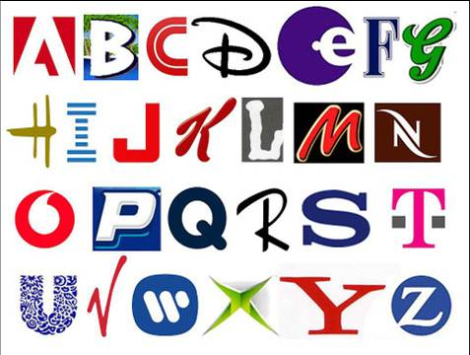  ____________________
Z____________________ | ____________________ | ____________________

----------------------------------------------------------------------------------------------------------

