6. Alphabet game
Grouping: 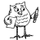

Worksheet 1
Try to make a word with every letter of the alphabet. The words must have something to do with this lesson about chocolate. Translate this word into your mother tongue and in another language you know.
English | Your mothertongue | Another language
A____________________ | ____________________ | ____________________
B____________________ | ____________________ | ____________________
C____________________ | ____________________ | ____________________
D____________________ | ____________________ | ____________________
E____________________ | ____________________ | ____________________
F____________________ | ____________________ | ____________________
G____________________ | ____________________ | ____________________
H____________________ | ____________________ | ____________________
I____________________ | ____________________ | ____________________
J____________________ | ____________________ | ____________________
K____________________ | ____________________ | ____________________
L____________________ | ____________________ | ____________________
M____________________ | ____________________ | ____________________
N____________________ | ____________________ | ____________________
O____________________ | ____________________ | ____________________
P____________________ | ____________________ | ____________________
Q____________________ | ____________________ | ____________________
R____________________ | ____________________ | ____________________
S____________________ | ____________________ | ____________________
T____________________ | ____________________ | ____________________
U____________________ | ____________________ | ____________________
V____________________ | ____________________ | ____________________
W____________________ | ____________________ | ____________________
X____________________ | ____________________ | ____________________
Y____________________ | ____________________ | 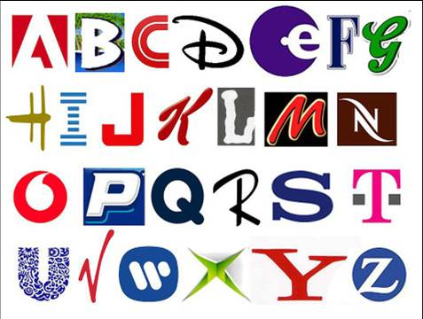  ____________________
Z____________________ | ____________________ | ____________________

